ODS Database Schema and UI validation Changes

|  |  |  |  |  |
| --- | --- | --- | --- | --- |
| **DataBase Schema details for ODS** | | | | |
| **Table Name** | **ColumnName** | **Size** | **Changes Required** | **Comments** |
| tblClinicalCommissioningGroup | CCG_Identifier | Varchar(5) | __ |  |
| tblClinicalCommissioningGroup_Audit |
| tblEpisode | Referrer_CCG_Code | Varchar(5) | __ | Changes are done in CN-6483 |
| tblEpisode_Audit |
| tblReferral | Referrer_CCG_Code | Varchar(5) | __ | Changes are done in CN-6483 |
| tblReferral_Audit |
| tblSLAMCareOptionOverride | Override_GP_CCG_Code,Override_Patient_CCG_Code | varcha(10) | __ |  |
| tblSLAMCareOptionOverride_Audit |
| tblSLAMCareOptionPart2 | Referral_CCG_Code | varcha(10) | __ |  |
| tblSLAMCareOptionPart2_Audit |
| tblCWPNTElectronicDischargeSummary | GP_Practice_Code | varcha(20) | __ |  |
| tblCWPNTElectronicDischargeSummary_Audit |
| tblCWPNTFallsRiskAssessmentTool | GP_Practice_Code | varchar(20) | __ |  |
| tblCWPNTFallsRiskAssessmentTool_Audit |
| tblEpisode | Practice_Code | varchar(20) | __ |  |
| tblEpisode_Audit |
| tblPractice | Practice_Code | varchar(20) | __ |  |
| tblPractice_Audit |
| tblReferral | Practice_Code | varchar(20) | __ |  |
| tblReferral_Audit |
| tblSLAMCareOptionOverride | Override_Practice_Code | varchar(20) | __ |  |
| tblSLAMCareOptionOverride_Audit |
| tblSLAMCareOptionPart2 | Referral_Practice_Code | varchar(20) | *__* |  |
| tblSLAMCareOptionPart2_Audit |
| tblSLAMNDTMS | GP_Practice_Code | varchar(255) | *__* |  |
| tblSLAMNDTMS_Audit |
| tblSLAMYPNDTMS | GP_Practice_Code | varchar(255) | *__* |  |
| tblSLAMYPNDTMS_Audit |
| ChildHealthDBSResponse | RegisteredGpPractice | nvarchar(12) | *__* | This table is in ChildHealth DB and this table will be updated through DBS service |

* Also searched for CCG in Child Health, Waiting List but we didn't find the table which is having CCG. IN child health DB we found the Practice code
* Looked into PatientDemographicsService(DBS generator) it will update only patient personal details. But the Childheatlth DBS will update the Practice Code to the ChildHealthDBSResponse table
* There is no foreign key reference for CCG code, there is a CCG_ID which was internally craeted by carenotes that CCG_ID is referenced to various tables**.**
* There is no foreign key reference for practice code, there is a Practice_ID which was internally craeted by carenotes that practice_ID is referenced to various tables**.**

**UI Validation details**

**SLAMExternalPlacement.aspx**

It’s a read-only field no need to change and there is no validations.

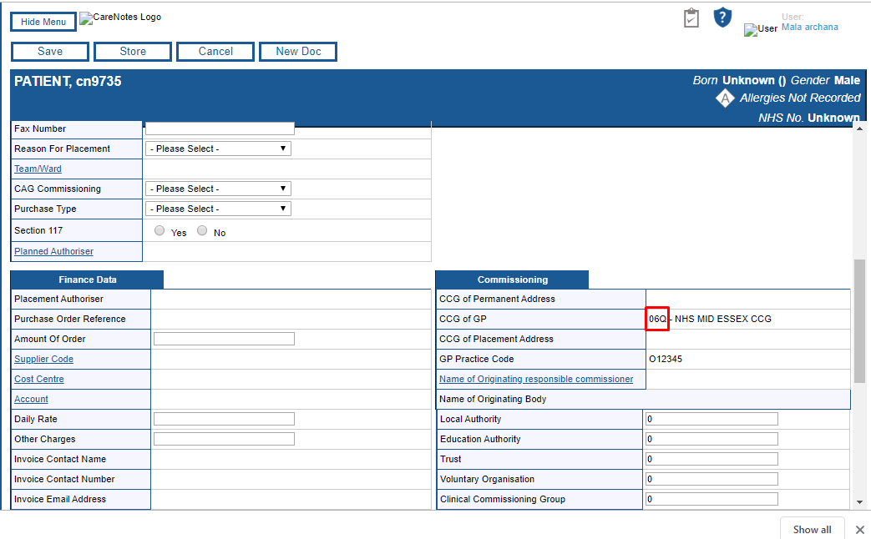

**CCG.aspx**

<asp:TextBox ID="CCGIdentifier" Width="50px" runat="server**" MaxLength="5"**></asp:TextBox>

The textfield max length has been restricted to 5 and there is no specific validations for CCG. general validations like mandatory field and checking for NULL exists.

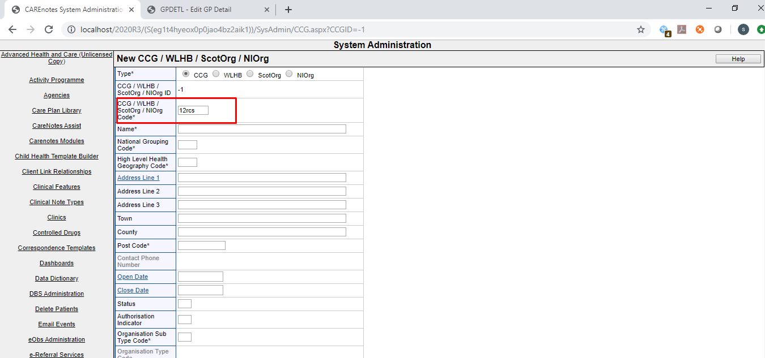

**ReferralDetails.ascx**

<asp:TextBox ID="ReferrerCCGCode" class="ReferralDetailsSection_ReferrerCCGCode" runat="server" Width="20" **MaxLength="10"**></asp:TextBox>

CCG will be autopopulated in the referral and Different Episode form when we click RegGP button we may need to change the CCG textbox size to display the CCG which has 5 character completely there is no specific validations here

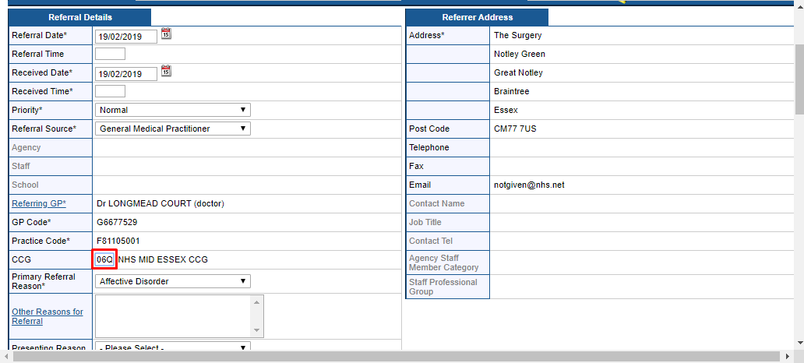

**SystemAdministaration\Location.aspx**

There is no validations for CCG. Works fine with 5character CCG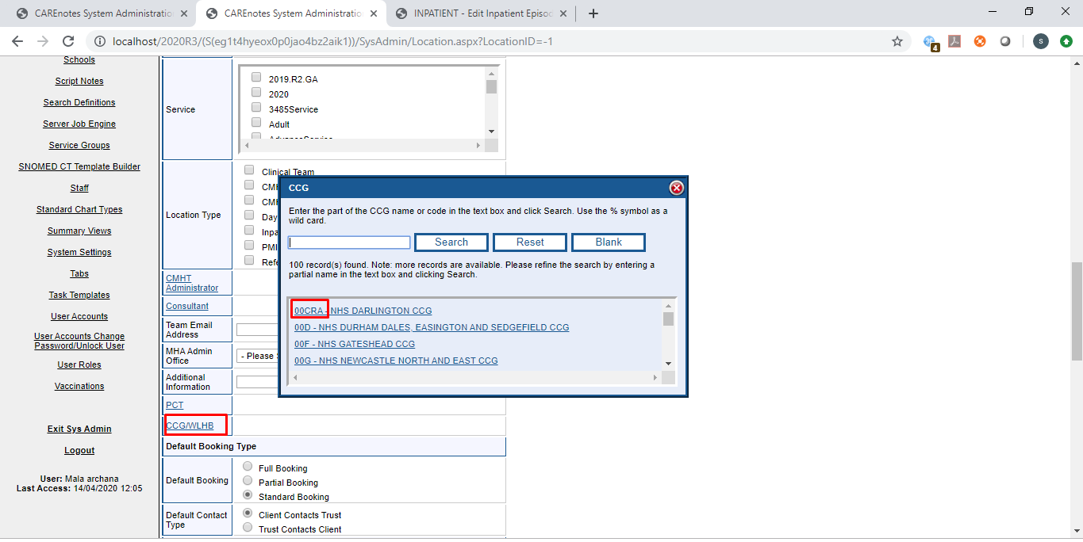

**S**[**LAM Inpatient Care Option**](javascript:%20EditForm(198);)**:**

The CCG id in the form is hidden and it can have 5 characters CCG id and there is no specific validations for CCG

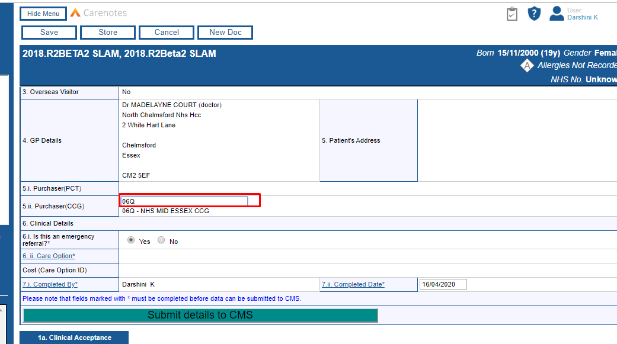

* Similarly we have the CCG for SLAM Outpatient daycareoption form

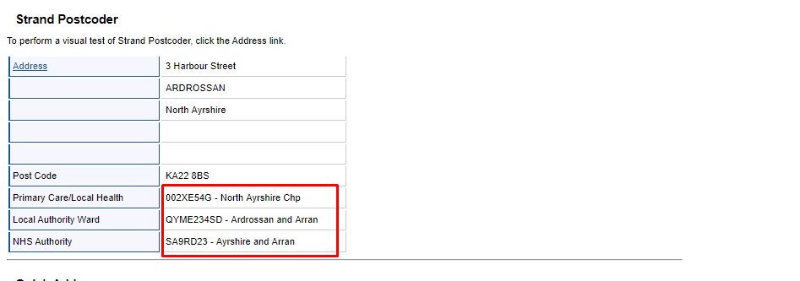

**Local Authority organization**

The text box length is restricted to 3 character.

The value(LA_ORG_Identifier) will be stored in the table tblLocalAuthorityOrganisation and the size of the column is Varchar(5)

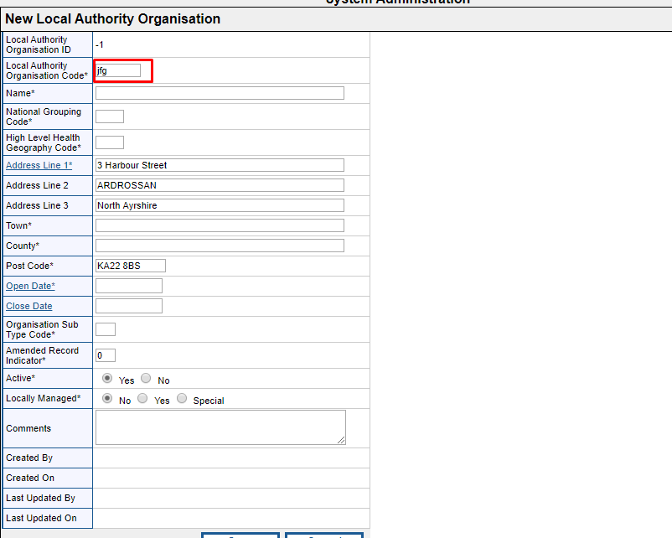

**Database mapping**

The ODS data will be stored in the following tables.

|  |  |  |
| --- | --- | --- |
| **csv File** | **Stored Procedure** | **Tables List** |
| niorg.csv | usp_UpdateClinicalCommissioningGroup, usp_UpdateClinicalCommissioningGroupPractice | tblClinicalCommissioningGroup, tblPractice, tblClinicalCommissioningGroupPractice |
| epctcur.csv | usp_UpdatePCT | tblPCT |
| npraccur.csv | usp_UpdatePractice | tblPractice, tblGPPractice |
| scotprac.csv | usp_UpdatePractice | tblPractice, tblGPPractice |
| epraccur.csv | usp_UpdatePractice | tblPractice, tblGPPractice |
| ebranchs.csv | usp_UpdatePractice | tblPractice, tblGPPractice |
| ngpcur.csv | usp_UpdateGP | tblGP, tblGPPractice |
| scotgp.csv | usp_UpdateGP | tblGP, tblGPPractice |
| egpcur.csv | usp_UpdateGP | tblGP, tblGPPractice |
| scotorg.csv | usp_UpdateClinicalCommissioningGroup, usp_UpdateClinicalCommissioningGroupPractice | tblClinicalCommissioningGroup, tblPractice, tblClinicalCommissioningGroupPractice |
| eccg.csv | usp_UpdateClinicalCommissioningGroup, usp_UpdateClinicalCommissioningGroupPractice | tblClinicalCommissioningGroup, tblPractice, tblClinicalCommissioningGroupPractice |
| wlhb.csv | usp_UpdateClinicalCommissioningGroup, usp_UpdateClinicalCommissioningGroupPractice | tblClinicalCommissioningGroup, tblPractice, tblClinicalCommissioningGroupPractice |
| epcmem.csv | usp_UpdateClinicalCommissioningGroup, usp_UpdateClinicalCommissioningGroupPractice | tblClinicalCommissioningGroup, tblPractice, tblClinicalCommissioningGroupPractice |
| nlhscgpr.csv | usp_UpdateClinicalCommissioningGroup, usp_UpdateClinicalCommissioningGroupPractice | tblClinicalCommissioningGroup, tblPractice, tblClinicalCommissioningGroupPractice |
| Lauth.csv | usp_UpdateLocalAuthorityOrganisation | tblLocalAuthorityOrganisation |

**Mapping of XML file data to Database**

* Mapping of XMl data to the particular table has to be done based on the RoleID When we parse the XMl file We identify the RoleId which is present in the Role tag (<Role id="RO141" uniqueRoleId="23494" primaryRole="true">) and the attribute primaryRole should be true. Single organization has multiple Roles but we need to select a role which is primary role.

For Example: Roleid=”RO98” is a role id for CCG and the data has to be mapped to tblClinicalCommissioningGrouptable

* Currently we are using CSV file and each CSV file data will be mapped to particular tables. But for XML, We get all the data in the single XML file and we need to differentiate the data based on the RoleId as mentioned above. We can identify which role data has to map to which table through (ORGANISATION REFERENCE DATA SCOPE DEFINITION.PDF) the PDF. which is attached along with this document.
* For some of the tables like **tblClinicalCommissioningGroup** and **tblLocalAuthorityOrganisation** we have some columns which can be mapped based on the Relationship.

tblLocalAuthorityOrganisation



tblClinicalCommissioningGroup



|  |  |  |
| --- | --- | --- |
| **Rel Type Id** | **Relationship Type Name** | **DB Table Column name** |
| RE4 | IS COMMISSIONED BY | CCG_Identifier |
| RE5 | IS LOCATED IN THE GEOGRAPHY OF | High_Level_Health_Geography_Code |
| RE2 | IS A SUB-DIVISION OF | National_Grouping_Code |

* When we parse the XMl we will get the Relation RE4 and from that Relation RE4 value we can find out RE5 and from RE5 we can get the values of RE2(Relationship Concept Explained In the below section)

**Mapping of API(XML) data to database**

* We can extract the Roles and Relationship data from the below URL

Relationships: https://directory.spineservices.nhs.uk/ORD/2-0-0/rels

Roles: [**https://directory.spineservices.nhs.uk/ORD/2-0-0/roles**](https://directory.spineservices.nhs.uk/ORD/2-0-0/roles)

* First we call the API with the URl

[**https://directory.spineservices.nhs.uk/ORD/2-0-0/sync?LastChangeDate=2020-03-15**](https://directory.spineservices.nhs.uk/ORD/2-0-0/sync?LastChangeDate=2020-03-15)

This will return the Organization list based on the parameter LastChangeData that we pass as a parameter.

* From the above APi call we extract all the organization list and we can extract the individual organization information from the below URL by passing the organization Code as a parameter

[**https://directory.spineservices.nhs.uk/ORD/2-0-0/organisations/A81001?_format=xml**](https://directory.spineservices.nhs.uk/ORD/2-0-0/organisations/A81001?_format=xml)

The data extracted for the organization **A81001** are as follows

<Organisation orgRecordClass="RC1">

<Name>THE DENSHAM SURGERY</Name>

<Date>

<Type value="Operational" />

<Start value="1974-04-01" />

</Date>

<OrgId root="2.16.840.1.113883.2.1.3.2.4.18.48" assigningAuthorityName="HSCIC" **extension="A81001"** />

<Status value="Active" />

<LastChangeDate value="2020-04-01" />

<GeoLoc>

<Location>

<AddrLn1>HEALTH CENTRE</AddrLn1>

<AddrLn2>LAWSON STREET</AddrLn2>

<AddrLn3>STOCKTON-ON-TEES</AddrLn3>

<Town>STOCKTON-ON-TEES</Town>

<County>CLEVELAND</County>

<PostCode>TS18 1HU</PostCode>

<Country>ENGLAND</Country>

</Location>

</GeoLoc>

<Contacts>

<Contact type="tel" value="01642 672351" />

</Contacts>

<Roles>

<**Role id="RO177"** uniqueRoleId="135947" **primaryRole="true"**>

<Date>

<Type value="Operational" />

<Start value="1974-04-01" />

</Date>

<Status value="Active" />

</Role>

<Role id="RO76" uniqueRoleId="179914">

<Date>

<Type value="Operational" />

<Start value="2014-04-15" />

</Date>

<Status value="Active" />

</Role>

</Roles>

<Rels>

<Rel id="RE8" uniqueRelId="610784">

<Date>

<Type value="Operational" />

<Start value="2019-10-01" />

</Date>

<Status value="Active" />

<Target>

<OrgId root="2.16.840.1.113883.2.1.3.2.4.18.48" assigningAuthorityName="HSCIC" extension="U89141" />

<PrimaryRoleId id="RO272" uniqueRoleId="388381" />

</Target>

</Rel>

<**Rel id="RE4"** uniqueRelId="631730">

<Date>

<Type value="Operational" />

<Start value="2020-04-01" />

</Date>

<**Status value="Active"** />

<Target>

<OrgId root="2.16.840.1.113883.2.1.3.2.4.18.48" assigningAuthorityName="HSCIC" **extension="16C"** />

<PrimaryRoleId id="RO98" uniqueRoleId="386505" />

</Target>

</Rel>

<Rel id="RE4" uniqueRelId="241242">

<Date>

<Type value="Operational" />

<Start value="2013-04-01" />

<End value="2020-03-31" />

</Date>

<Status value="Inactive" />

<Target>

<OrgId root="2.16.840.1.113883.2.1.3.2.4.18.48" assigningAuthorityName="HSCIC" extension="00K" />

<PrimaryRoleId id="RO98" uniqueRoleId="161394" />

</Target>

</Rel>

<Rel id="RE4" uniqueRelId="241241">

<Date>

<Type value="Operational" />

<Start value="1999-04-01" />

<End value="2001-03-31" />

</Date>

<Status value="Inactive" />

<Target>

<OrgId root="2.16.840.1.113883.2.1.3.2.4.18.48" assigningAuthorityName="HSCIC" extension="4QP36" />

<PrimaryRoleId id="RO171" uniqueRoleId="83827" />

</Target>

</Rel>

<Rel id="RE4" uniqueRelId="241240">

<Date>

<Type value="Operational" />

<Start value="2001-04-01" />

<End value="2013-03-31" />

</Date>

<Status value="Inactive" />

<Target>

<OrgId root="2.16.840.1.113883.2.1.3.2.4.18.48" assigningAuthorityName="HSCIC" extension="5E1" />

<PrimaryRoleId id="RO179" uniqueRoleId="76483" />

</Target>

</Rel>

</Rels>

</Organisation>

* From the above link we have extracted the particular Organization data and based on the Role id we will decide to which table data has to be mapped for example if the role id is RO98 then the data has to be mapped to **tblClinicalCommissioningGroup** and this table has some columns like (High_Level_Health_Geography_Code and National_Grouping_Code) for these columns data can be mapped through relationship which is explained below.
* A particular organization data may have multiple relationship we need to choose the relation which doesnot have enddate or status should be active
* After extracting the organization from the above link we need to find the active relationship the relation **RE4** is a **CCG_identifier** value

<**Rel id="RE4"** uniqueRelId="631730">

<Date>

<Type value="Operational" />

<Start value="2020-04-01" />

</Date>

**<Status value="Active" />**

<Target>

<OrgId root="2.16.840.1.113883.2.1.3.2.4.18.48" assigningAuthorityName="HSCIC" **extension="16C"** />

<PrimaryRoleId id="RO98" uniqueRoleId="386505" />

</Target>

</Rel>

Then we need to call the API with the active Relationship value that is **16C** as a parameter

[**https://directory.spineservices.nhs.uk/ORD/2-0-0/organisations/16C?_format=xml**](https://directory.spineservices.nhs.uk/ORD/2-0-0/organisations/16C?_format=xml)

From the above URL again we need to find the active relationship that is **RE5** which is the value for the column **High_Level_Health_Geography_Code = QHM**

<Rel id="RE5" uniqueRelId="619574">

<Date>

<Type value="Operational" />

<Start value="2019-10-23" />

</Date>

<Date>

<Type value="Legal" />

<Start value="2020-04-01" />

</Date>

**<Status value="Active" />**

<Target>

<OrgId root="2.16.840.1.113883.2.1.3.2.4.18.48" assigningAuthorityName="HSCIC" **extension="QHM"** />

<PrimaryRoleId id="RO261" uniqueRoleId="303773" />

</Target>

</Rel>

Again we need to call the API with the active Relationship value that is **QHM** as a parameter

[**https://directory.spineservices.nhs.uk/ORD/2-0-0/organisations/QHM?_format=xml**](https://directory.spineservices.nhs.uk/ORD/2-0-0/organisations/QHM?_format=xml)

From the above URL again we need to find the active relationship that is **RE2** which is the value for the column **National_Grouping_Code = Y63**

<**Rel id="RE2"** uniqueRelId="619609">

<Date>

<Type value="Operational" />

<Start value="2019-12-09" />

</Date>

<Date>

<Type value="Legal" />

<Start value="2020-04-01" />

</Date>

**<Status value="Active" />**

<Target>

<OrgId root="2.16.840.1.113883.2.1.3.2.4.18.48" assigningAuthorityName="HSCIC" **extension="Y63"** />

<PrimaryRoleId id="RO209" uniqueRoleId="309123" />

</Target>

</Rel>